



CS3711- SUMMER INTERNSHIP REPORT

**ANNA UNIVERSITY REGIONAL CAMPUS TIRUNELVELI**

**SUBMITTED BY:**

**ANISHA A**

**950021104005**

**DEPT: COMPUTER SCIENCE AND ENGINEERING**

**TABLE OF CONTENTS:**

|  |  |  |
| --- | --- | --- |
| **S. No** | **Title** | **Page no** |
| **1.** | **Introduction** | **3** |
| **2.** | **Company profile** | **4** |
| **3.** | **Training activities**   * **Week1** * **Week2** * **Week3** * **Week4** | **10** |
| **4.** | **Skills acquired** | **21** |
| **5.** | **Challenges faced** | **25** |
| **6.** | **conclusion** | **27** |
| **7.** | **acknowledgement** | **28** |
| **8.** | **appendix** | **29** |

**1. INTRODUCTION:**

The purpose of this internship was to gain practical experience and insights into front-end development within a professional setting. This opportunity allowed me to apply theoretical knowledge from my academic coursework to real-world projects, enhance my technical skills, and understand the dynamics of working in a team-oriented environment in the field of web development. The internship duration was from 05-07-2024 to 03-08-2024. I completed my internship at Bevywise Networks LLP, located at Shah Complex, 43/S6, Trivandrum Rd, Kattnayakan, Palayamkottai, Tirunelveli, Tamil Nadu 627002.

**2.COMPANY PROFILE :**

* Company Name: Bevywise Networks
* Company Overview: <https://www.bevywise.com/>

Bevywise Networks was established with a clear focus on pioneering advancements in the Internet of Things (IoT) technology. The company was founded to address the growing need for reliable, scalable, and efficient IoT communication tools and platforms that cater to a variety of industries.

Headquarters: Tirunelveli, Tamil Nadu, India.

* Core Business Areas:

Bevywise Networks specializes in providing advanced software tools and solutions for the Internet of Things (IoT). The company’s core business areas include the following main products and services:

* MQTTRoute (MQTT Broker):

MQTTRoute is a high-performance MQTT broker designed for managing communication between IoT devices. MQTT (Message Queuing Telemetry Transport) is a lightweight messaging protocol commonly used in IoT networks for efficient, real-time data transmission.

* IoT Simulator:

The IoT Simulator allows businesses and developers to simulate large-scale IoT environments. This tool is essential for testing and validating IoT systems before they are deployed in real-world settings.

* IoT Platform:

Bevywise Networks offers a comprehensive IoT platform that integrates device management, data collection, and real-time analytics. This platform serves as a centralized hub for managing IoT operations.

* Consultancy and Custom Solutions:

Bevywise Networks provides consultancy services to help businesses design and implement tailored IoT strategies. The company works closely with clients to understand their unique needs and deliver customized IoT solutions.

* Industry-Specific IoT Applications:

Bevywise Networks develops and offers industry-specific IoT applications to address the unique challenges of different sectors.

Bevywise Networks' core business areas revolve around providing robust, scalable, and customizable IoT solutions that cater to the diverse needs of businesses across multiple industries. Their products and services are designed to simplify the implementation and management of IoT infrastructure, enabling businesses to fully leverage the potential of IoT technology.

Their work has had a significant impact on improving operational efficiency, sustainability, and service delivery in different sectors.

**3. TRAINING ACTIVITIES :**

**WEEK 1:**

**Tasks Assigned:**

1. **Environment Setup:**
   * Installed and configured essential software like Visual Studio Code and Node.js to set up the development environment.
   * Ensured that all required libraries and frameworks, such as React.js, were installed and properly configured for seamless web development.
2. **Home Page Design:**
   * Designed the layout of the home page with a focus on user-friendly navigation and modern aesthetics.
   * Created the navigation bar with links to Home, Courses, About, and Contact pages.
   * Developed a banner section showcasing featured courses and a call-to-action button to encourage sign-ups.
   * Included sections for showcasing the latest courses, each with "Enroll Now" buttons for easy course registration.
   * Designed a basic contact form for customer inquiries to ensure potential students can easily reach out.

**Learning Outcomes:**

* Gained proficiency in setting up and configuring a development environment with essential tools and software.
* Enhanced my understanding of front-end design principles, particularly in creating user-friendly and visually appealing web pages.
* Learned to design and implement a cohesive and functional home page, focusing on navigation, layout, and user experience.
* Developed skills in HTML, CSS, and basic JavaScript to create interactive and responsive web elements.
* Acquired knowledge of the importance of planning and structuring a website's layout before diving into coding.

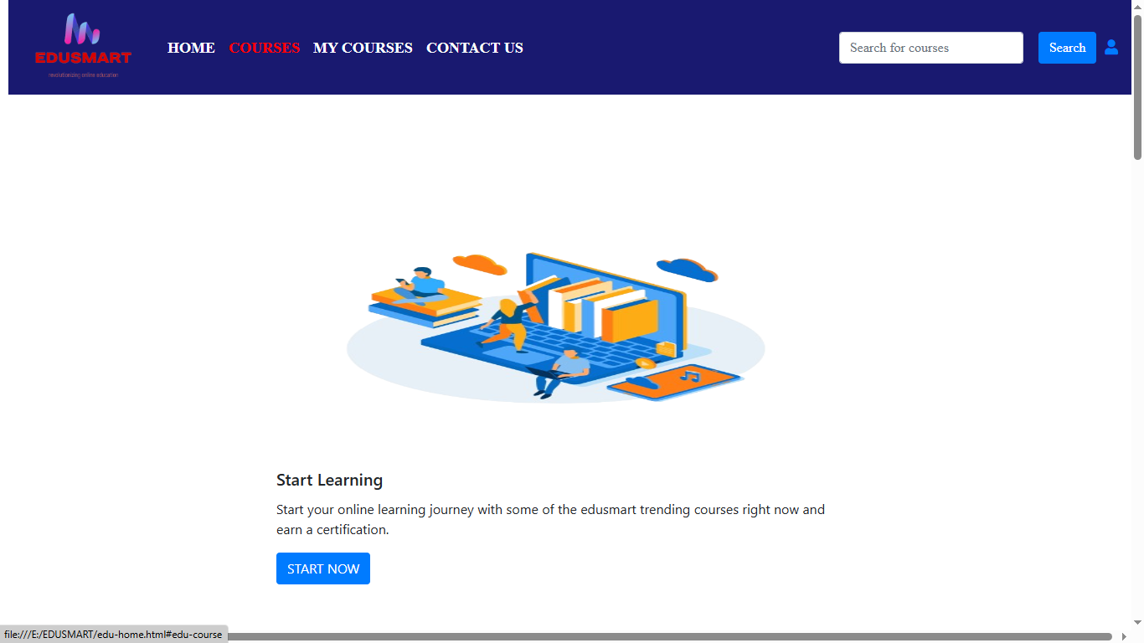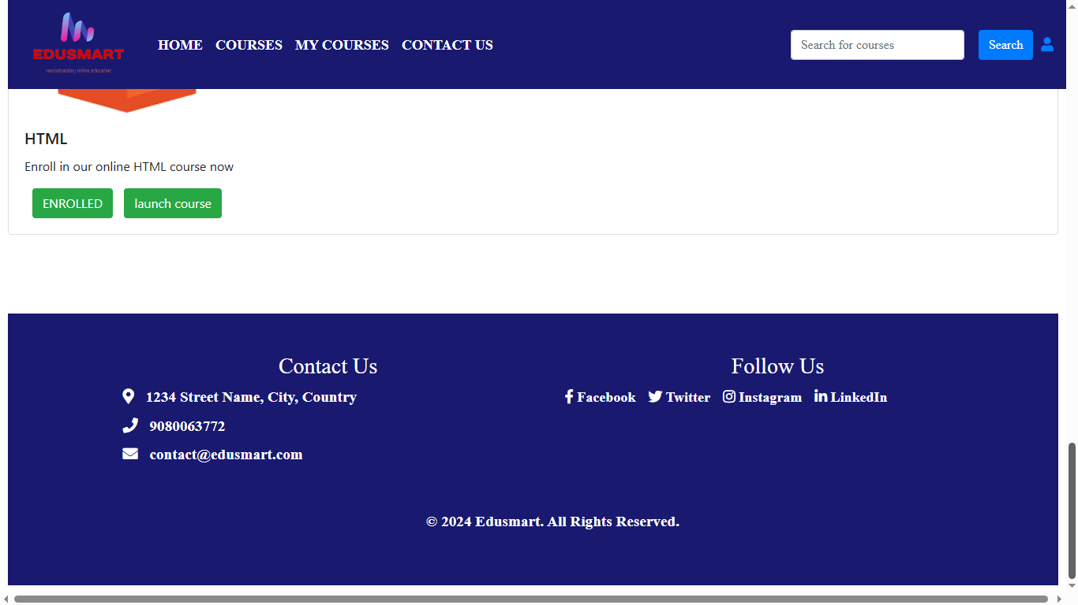

**WEEK 2:**

**Course Categories and Course Pages Development**

**Tasks Assigned:**

1. **Course Categories Page Development:**
   * Designed and developed the course categories page, allowing users to browse courses by categories such as Programming, Web Development, and Cloud Computing.
   * Implemented functionality to dynamically display categories, making it easier for users to navigate and find courses of interest.
   * Integrated filtering options so that users can quickly narrow down their search within a specific category.
2. **Course Page Development:**
   * Built the course listing page, displaying various courses with details such as images, names, descriptions, prices, and "Enroll Now" buttons.
   * Implemented sorting features to allow users to sort courses by popularity, latest additions, or ratings.
   * Ensured that course details were dynamically loaded from a database, allowing for easy updates and scalability.

**Learning Outcomes:**

* Enhanced skills in front-end development, specifically in creating dynamic and user-friendly interfaces for course categories and course pages.
* Gained experience in integrating and managing data from databases, ensuring that course information is efficiently loaded and displayed.
* Improved understanding of user experience design, focusing on making course navigation and filtering intuitive and efficient for users.
* Developed problem-solving skills by addressing challenges related to dynamic data integration and page responsiveness across different devices.
* Learned to implement sorting and filtering features, improving the overall functionality and usability of the platform.

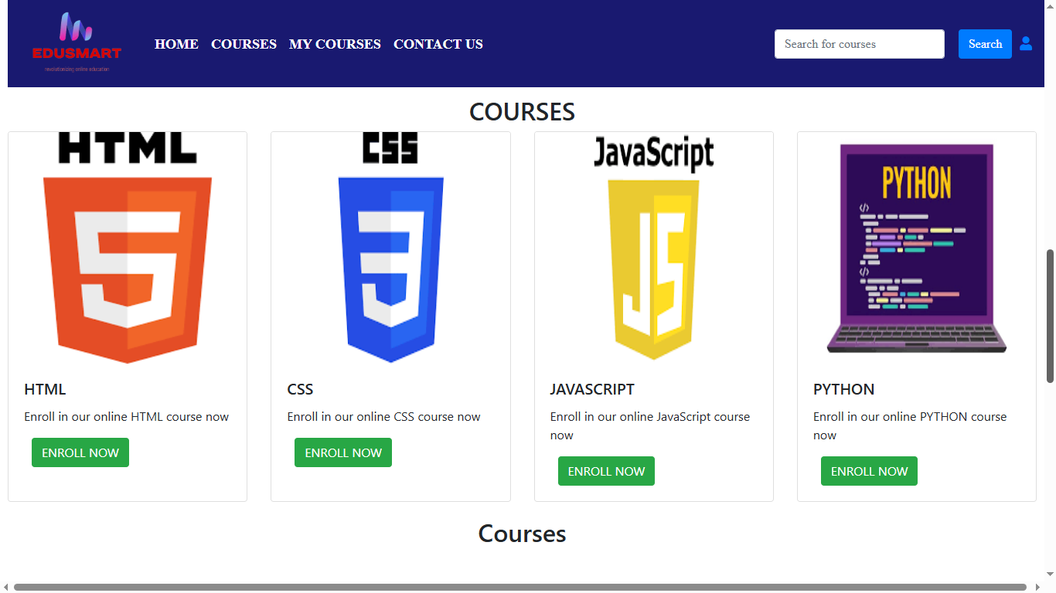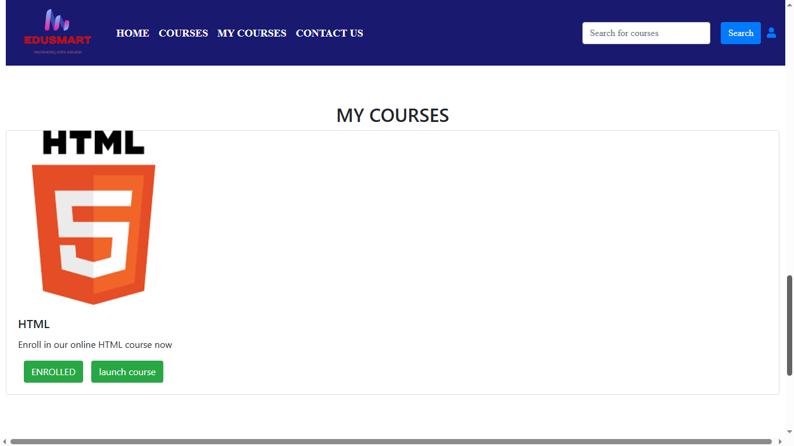

**WEEK 3:**

**User and Admin Login, Admin Dashboard Development**

**Tasks Assigned:**

1. **User and Admin Login Pages:**
   * Developed separate login pages for users and admins, incorporating forms for entering credentials such as username and password.
   * Implemented authentication mechanisms to verify user and admin credentials, ensuring secure access to different parts of the platform.
2. **Admin Dashboard Layout:**
   * Designed the layout of the admin dashboard, including navigation links to sections such as Dashboard, Users, Courses, Orders, Settings, and Logout.
   * Created a profile section displaying admin details and an "Edit Profile" button to manage admin information.
3. **CRUD Operations:**
   * Developed functionality for the admin to perform CRUD (Create, Read, Update, Delete) operations on courses and categories.
   * Implemented a user interface that allows the admin to add new courses and categories, edit existing ones, and delete items as needed.
   * Ensured proper validation and error handling for all admin actions to maintain data integrity and prevent issues.

**Learning Outcomes:**

* Gained a comprehensive understanding of developing secure login systems for different user roles, enhancing my knowledge of authentication and authorization.
* Enhanced my skills in designing and implementing administrative interfaces, focusing on usability and functionality for efficient management.
* Learned to implement CRUD operations, providing a solid foundation for managing dynamic data within a web application.
* Improved problem-solving skills by addressing challenges related to data management and user interface design for the admin dashboard.
* Acquired experience in ensuring data validation and error handling, emphasizing the importance of maintaining data integrity and user experience.
* Developed an understanding of the importance of role-based access control in web applications, ensuring that different users have appropriate access levels. 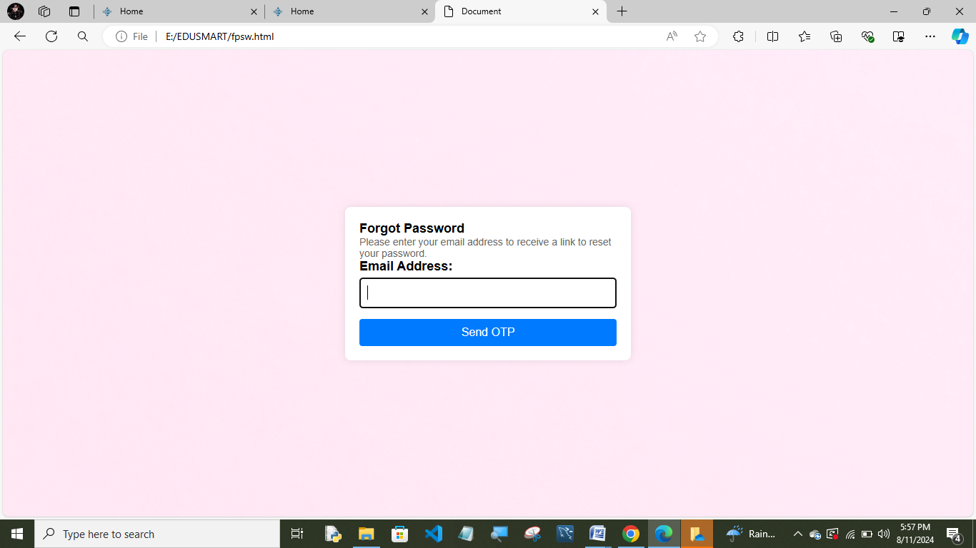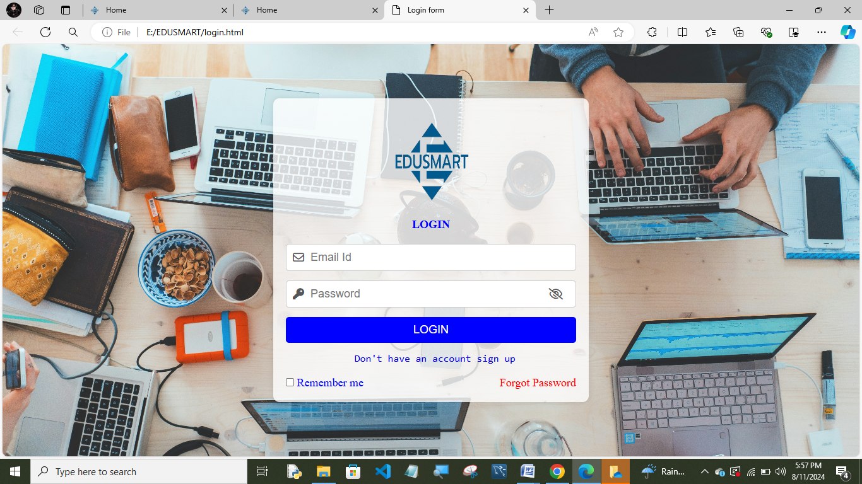 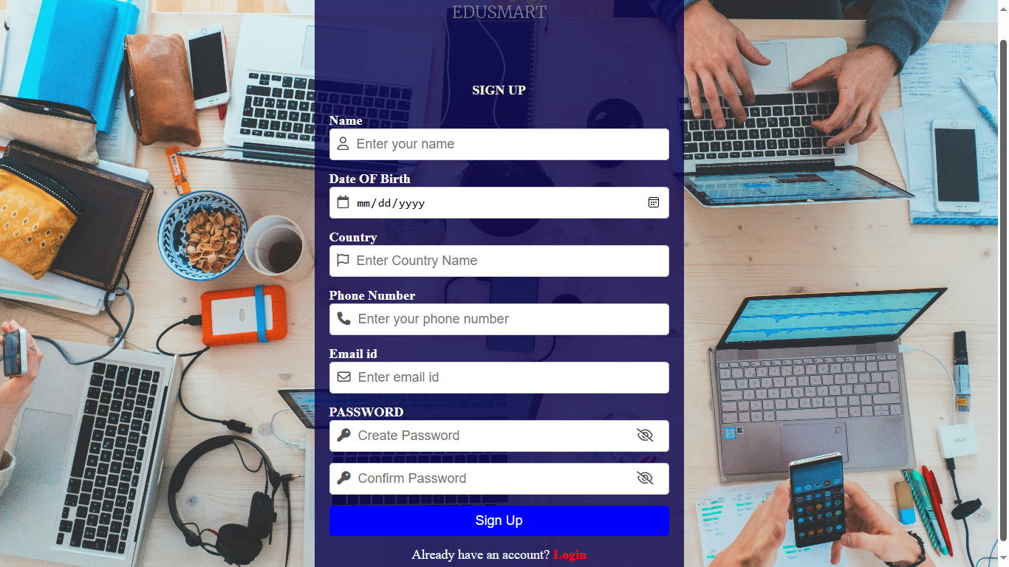

**WEEK 4:**

**Social Media Integration and JavaScript Enhancements**

**Tasks Assigned:**

1. **Social Media Integration:**
   * Integrated social media sharing buttons for popular platforms such as Facebook, Twitter, and LinkedIn.
   * Enabled users to share courses and pages directly from the platform to their social media accounts, increasing the platform's reach and engagement.
2. **JavaScript Enhancements:**
   * Added interactive features using JavaScript to enhance the user experience on the platform.
   * Implemented dynamic content loading to improve the efficiency and responsiveness of the platform.
   * Developed interactive elements such as sliders, modals, and tooltips to make the interface more engaging and user-friendly.
   * Enhanced form validation and submission processes using JavaScript for a smoother user experience.

**Learning Outcomes:**

* Gained proficiency in integrating social media functionalities into a web application, understanding the importance of user engagement and content sharing.
* Improved JavaScript skills, particularly in creating dynamic and interactive web elements that enhance user experience.
* Learned to implement and manage dynamic content loading, improving the performance and responsiveness of the platform.
* Developed a better understanding of user interface design by incorporating interactive elements such as sliders, modals, and tooltips.
* Enhanced knowledge of client-side scripting and its role in form validation and submission processes.
* 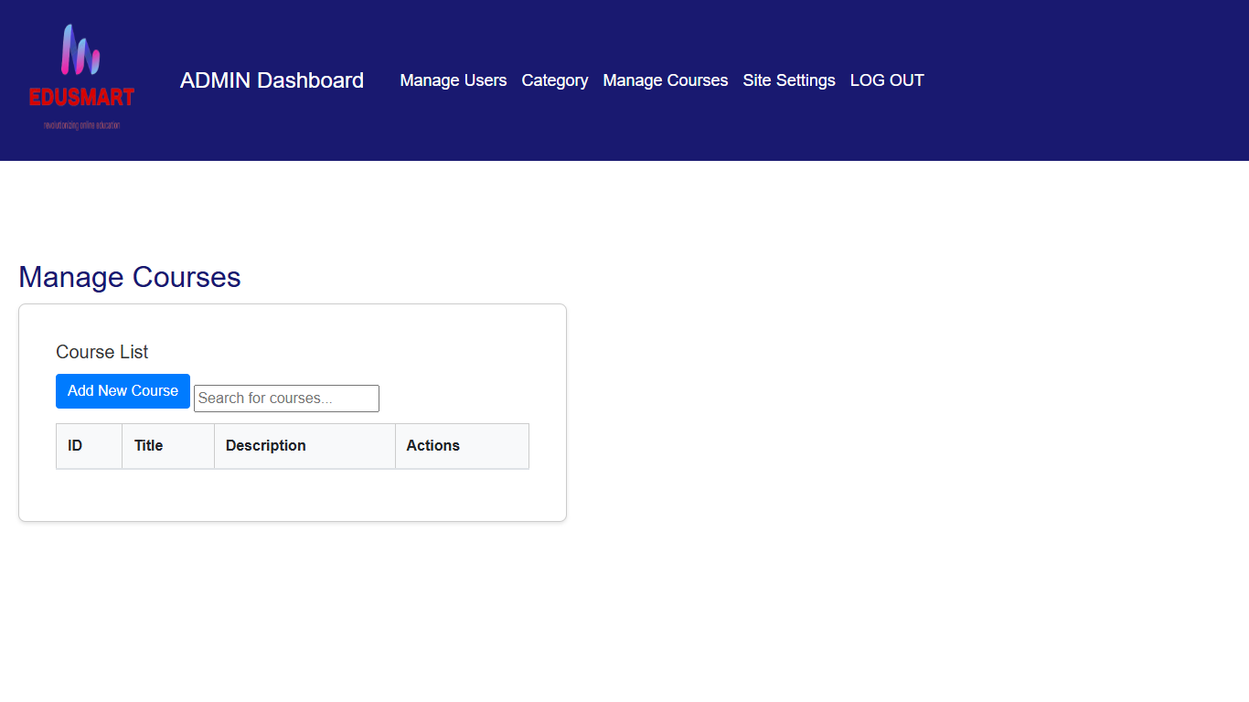Acquired experience in using JavaScript to create a more interactive and engaging web application, emphasizing the importance of user-centric design.

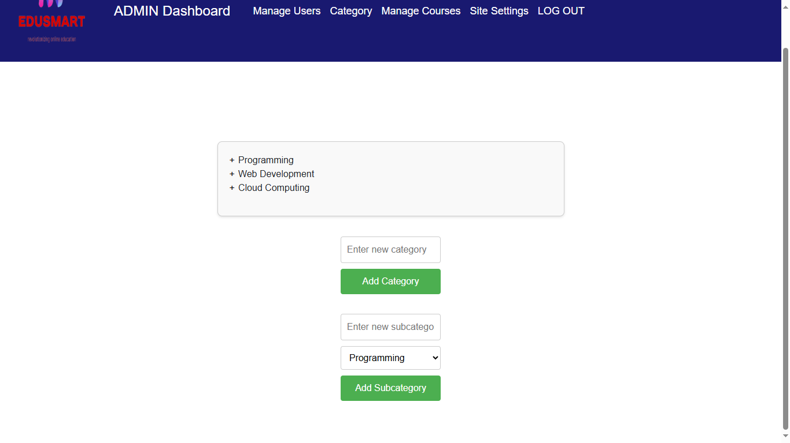

**4. Skills Acquired :**

**Technical Skills:**

* **Front-End Development:** Proficiency in HTML, CSS, and JavaScript for creating responsive and interactive web pages.
* **Back-End Development:** Experience with setting up development environments and implementing CRUD operations.
* **Authentication and Security:** Skills in developing secure user and admin login systems.
* **Database Management:** Knowledge in integrating databases for dynamic content loading.
* **UI/UX Design:** Improved design skills for user-friendly interfaces and social media integration.

**Soft Skills:**

* **Communication:** Enhanced through regular interactions and discussions with team members.
* **Teamwork:** Improved by collaborating with colleagues on project tasks.
* **Problem-Solving:** Strengthened by addressing and resolving technical challenges.
* **Time Management:** Developed through effective task planning and prioritization.
* **Adaptability:** Gained by quickly learning new tools and technologies.Bottom of Form

**5. Challenges Faced:**

**Description of Challenges:**

1. **Integrating Social Media Features:**
   * Difficulty in ensuring compatibility across different social media platforms and browsers.
2. **Secure Authentication:**
   * Challenges in implementing a robust authentication system for both user and admin login to ensure security.
3. **Responsive Design:**
   * Ensuring that the website design was responsive and functioned well on various devices and screen sizes.
4. **Data Management:**
   * Managing dynamic data loading and CRUD operations efficiently within the admin dashboard.

**Solutions:**

1. **Integrating Social Media Features:**
   * Conducted thorough research on social media APIs and used standardized libraries to ensure compatibility and seamless integration.
2. **Secure Authentication:**
   * Utilized well-documented authentication libraries and followed best practices for securing login systems, such as hashing passwords and using secure sessions.
3. **Responsive Design:**
   * Implemented responsive design principles using CSS media queries and flexible grid layouts, and tested the website on different devices and browsers.
4. **Data Management:**
   * Used efficient database queries and proper data validation techniques to manage dynamic data loading and CRUD operations effectively, ensuring data integrity and performance.

**6. CONCLUSION:**

My internship at Bevywise Networks LLP was a highly enriching experience that significantly enhanced my technical and soft skills. Over the course of four weeks, I gained hands-on experience in front-end and back-end web development, developed secure authentication systems, integrated dynamic data management, and implemented social media features. These experiences allowed me to apply theoretical knowledge to real-world projects, understand the nuances of professional web development, and work effectively within a team.

The knowledge and skills I acquired during this internship will be invaluable in my future academic and professional pursuits. I plan to apply my enhanced technical skills in future web development projects, both in academic settings and personal endeavors. The problem-solving abilities and experience in secure authentication will be crucial as I tackle more complex projects. Additionally, the soft skills I developed, such as communication, teamwork, and adaptability, will help me excel in collaborative environments and adapt to new challenges in the tech industry. This internship has provided a strong foundation for my growth as a web developer and has prepared me for future professional opportunities.

**7. ACKNOWLEDGEMENT:**

I would like to extend my heartfelt gratitude to my mentors and colleagues at Bevywise Networks LLP. Their guidance, support, and encouragement throughout the internship were invaluable. Special thanks to Sakthi Jothi, who provided constant supervision and insightful feedback, helping me navigate challenges and enhance my skills. I am also grateful to my colleagues who shared their expertise and collaborated with me on various aspects of the project.

I am deeply thankful to Bevywise Networks LLP for providing me with this incredible opportunity. The chance to work on meaningful projects in a professional environment has been an enriching experience. I appreciate the company's commitment to fostering a learning environment and the trust they placed in me to contribute to their projects. This internship has been a pivotal step in my professional development, and I am grateful for the experience and the support provided by the entire team.

8. APPENDICES:

